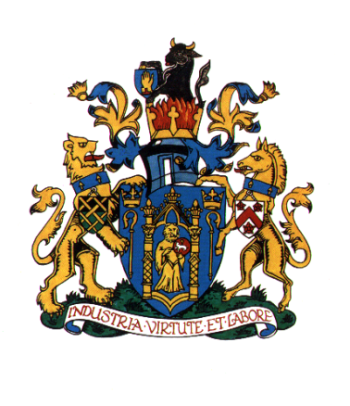
YEOVIL TOWN COUNCIL

COMPLAINTS HANDLING PROCEDURE
- Yeovil Town Council is committed to providing a quality service for the benefit of the people who live, work or visits its area. If you are dissatisfied with the standard of service you have received from this Council, or are unhappy about an action or lack of action by this Council, this Complaints Procedure sets out how you may complain to the Council and how we shall try to resolve your complaint.

- This Complaints Procedure applies to complaints about Council administration and procedures and may include complaints about how Council employees have dealt with your concerns.

- This Complaints Procedure does not apply to:
- Complaints by one employee against another employee, or between a Council employee and the Council as employer. These matters are dealt with under the Council’s disciplinary and grievance procedures.
- Complaints against Councillors. Complaints against Councillors are covered by the Code of Conduct for Members adopted by the Council on 7th August 2012 and, if a complaint against a Councillor is received by the Council, it will be referred under the Code of Conduct to South Somerset District Council. Further information on the process of dealing with complaints against Councillors may be obtained from the Monitoring Officer of South Somerset District Council.

- The appropriate time for influencing Council decision-making is by raising your concerns before the Council debates and votes on a matter. You may do this by writing to the Council in advance of the meeting at which the item is to be discussed. There may also be the opportunity to raise your concerns in the public participation section of Council meetings. If you are unhappy with a Council decision, you may raise your concerns with the Council, but Standing Orders prevent the Council from re-opening issues for six months from the date of the decision, unless there are exceptional grounds to consider this necessary and the special process set out in the Standing Orders is followed.
- You may make your complaint about the Council’s procedures or administration to the Clerk. You may do this in person, by phone, or by writing to or emailing the Clerk. The addresses and numbers are set out below.

- Wherever possible, the Clerk will try to resolve your complaint immediately. If this is not possible, the Clerk will normally acknowledge your complaint within five working days.

- If you do not wish to report your complaint to the Clerk, you may make your complaint directly to the Chairman of the Council who will report your complaint to the Policy, Resources and Finance Committee or to the Council (as appropriate).

- The Clerk or the Policy, Resources and Finance Committee or the Council (as appropriate) will investigate each complaint, obtaining further information as necessary from you and/or from staff or members of the Council.

- The Clerk or the Chairman of the Council will notify you within 20 working days of the outcome of your complaint and of what action (if any) the Council proposes to take as a result of your complaint. (In exceptional cases the twenty working days timescale may have to be extended. If it is, you will be kept informed.)

- If you are dissatisfied with the response to your complaint, you may ask for your complaint to be referred to the Policy, Resources and Finance Committee or the Council (as appropriate) and (usually within eight weeks) you will be notified in writing of the outcome of the review of your original complaint.

Contacts

Amanda Card – Town Clerk The Mayor
Yeovil Town Council Yeovil Town Council
Town House Town House
19 Union Street 19 Union Street
YEOVIL YEOVIL
Somerset Somerset
BA20 1PQ BA20 1PQ
town.clerk@yeovil.gov.uk mayor@yeovil.gov.uk

Yeovil Town Council
24th September 2019

To be reviewed: September 2024

